Physical Topology

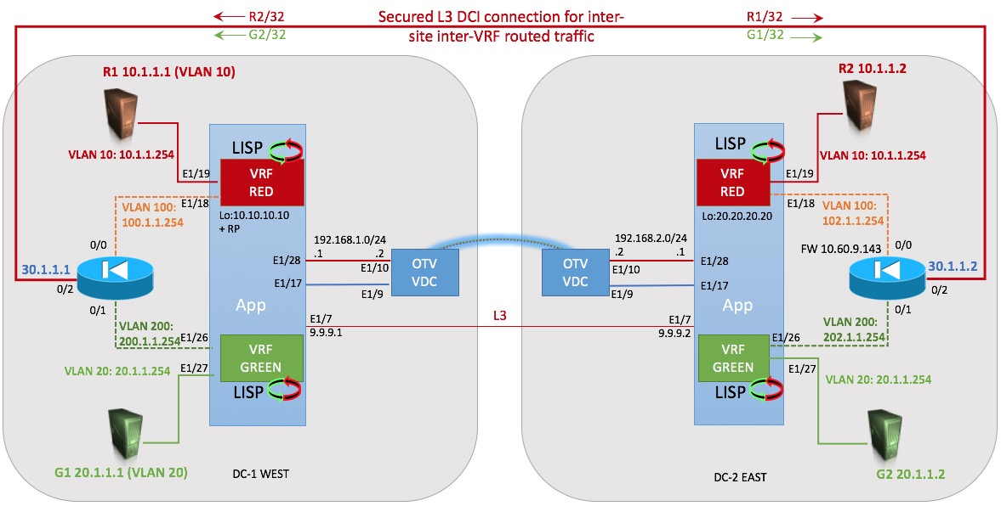

Logical Topology
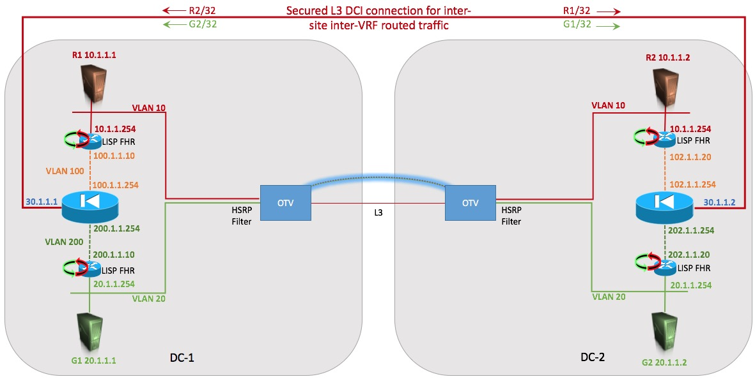

Please, note that the configurations given below can certainly be clean-up and tuned. Some commands are still embedded for testing purposes.
Note also that the text highlighted in yellow delimits the optional CLI configuration for the LISP Map-server as a backup mechanism used for the endpoint notifications, however it is strongly recommended to enable the map-server.

DC-1

LISP IGP ASSIST

hostname DC-1-App

feature ospf
feature pim
feature lisp
feature interface-vlan
feature hsrp

username admin password 5 $5$Kmvcx74m$O72Q6kalrKvrI2YUSuWZNSn9uOJ9DvDRdThjJIICE43 role vdc-admin
no password strength-check
ip domain-lookup
snmp-server user admin vdc-admin auth md5 0x97398a8af05b050f6493212b17e58757 priv 0x97398a8af05b050f6493212b17e58757 localizedkey
rmon event 1 log description FATAL(1) owner PMON@FATAL
rmon event 2 log description CRITICAL(2) owner PMON@CRITICAL
rmon event 3 log description ERROR(3) owner PMON@ERROR
rmon event 4 log description WARNING(4) owner PMON@WARNING
rmon event 5 log description INFORMATION(5) owner PMON@INFO

ip pim rp-address 10.10.10.10 group-list 224.0.0.0/4
ip pim ssm range 232.0.0.0/8
!
! Start:
! LISP MAP-SERVER Alternative notification process
! This is optional but recommended as alternative/backup
! solution for EID notification
ip lisp itr-etr
ip lisp map-server
lisp site DATA_CENTER
eid-prefix 10.1.0.0/16 instance-id 1 accept-more-specifics
eid-prefix 20.1.0.0/16 instance-id 2 accept-more-specifics
authentication-key 3 9125d59c18a9b015
ip lisp locator-vrf default
ip lisp etr map-server 10.10.10.10 key 3 9125d59c18a9b015
ip lisp etr map-server 20.20.20.20 key 3 9125d59c18a9b015
!
! End-of LISP MAP-SERVER
!

vlan 1,10,20,100,200,210

ip prefix-list HOST-ROUTES seq 5 permit 0.0.0.0/0 eq 32
route-map ADV-HOST-ROUTES deny 5
match interface Null0
route-map ADV-HOST-ROUTES permit 10
match ip address prefix-list HOST-ROUTES
vrf context GREEN
ip pim ssm range 232.0.0.0/8
ip lisp itr-etr
lisp instance-id 2
ip lisp locator-vrf default
lisp dynamic-eid LISP_EXTENDED_SUBNET
database-mapping 20.1.1.0/24 10.10.10.10 priority 1 weight 50
map-notify-group 239.1.1.2
no route-export away-dyn-eid
vrf context RED
ip pim ssm range 232.0.0.0/8
ip lisp itr-etr
lisp instance-id 1
ip lisp locator-vrf default
lisp dynamic-eid LISP_EXTENDED_SUBNET
database-mapping 10.1.1.0/24 10.10.10.10 priority 1 weight 50
map-notify-group 239.1.1.1
no route-export away-dyn-eid
vrf context management

interface mgmt0
vrf member management

interface Vlan10
no shutdown
vrf member RED
lisp mobility LISP_EXTENDED_SUBNET
lisp extended-subnet-mode
ip address 10.1.1.251/24
ip ospf passive-interface
ip pim sparse-mode
hsrp 10
preempt
priority 110
ip 10.1.1.254

interface Vlan20
no shutdown
vrf member GREEN
lisp mobility LISP_EXTENDED_SUBNET
lisp extended-subnet-mode
ip address 20.1.1.251/24
ip ospf passive-interface
ip pim sparse-mode
hsrp 20
preempt
priority 110
ip 20.1.1.254

interface Vlan100
no shutdown
vrf member RED
ip address 100.1.1.10/24
ip router ospf 100 area 0.0.0.0

interface Vlan200
no shutdown
vrf member GREEN
ip address 200.1.1.10/24
ip router ospf 100 area 0.0.0.0

interface Ethernet1/7
mtu 9216
ip address 9.9.9.1/24
ip ospf network point-to-point
ip router ospf 1 area 0.0.0.0
ip pim sparse-mode
no shutdown

interface Ethernet1/17
switchport
switchport mode trunk
switchport trunk allowed vlan 10,20,210

interface Ethernet1/18
switchport
switchport access vlan 100

interface Ethernet1/19
switchport
switchport access vlan 10

interface Ethernet1/26
switchport
switchport access vlan 200

interface Ethernet1/27
switchport
switchport access vlan 20

interface Ethernet1/28
ip address 192.168.1.1/24
ip ospf network point-to-point
ip router ospf 1 area 0.0.0.0
ip pim sparse-mode
no shutdown

interface loopback10
description LISP Loopback
ip address 10.10.10.10/32
ip router ospf 1 area 0.0.0.0
ip pim sparse-mode

cli alias name wr copy run start
cli alias name back switchback
line vty
router ospf 100
router-id 1.1.1.1
vrf GREEN
redistribute lisp route-map ADV-HOST-ROUTES
vrf RED
redistribute lisp route-map ADV-HOST-ROUTES
no system default switchport shutdown

ASA Firewall

ASA Version 9.1(5)
!
hostname FW-DC-1
enable password B2OJ16CjxKNubigD encrypted
names
!
interface GigabitEthernet0/0
nameif RED
security-level 100
ip address 100.1.1.254 255.255.255.0
ospf cost 10
ospf authentication null
!
interface GigabitEthernet0/1
nameif GREEN
security-level 100
ip address 200.1.1.254 255.255.255.0
ospf cost 10
ospf authentication null
!
interface GigabitEthernet0/2
nameif Inter-DMZ
security-level 100
ip address 30.1.1.1 255.255.255.0
ospf cost 10
ospf authentication null
!
!
interface Management0/0
management-only
nameif management
security-level 100
ip address 10.60.9.142 255.255.255.0
!
banner login Viva España
ftp mode passive
same-security-traffic permit inter-interface
same-security-traffic permit intra-interface
object-group icmp-type ICMP-traceroute-full
description Allo ICMP Traceroute
icmp-object echo
icmp-object echo-reply
icmp-object information-reply
icmp-object information-request
icmp-object mask-reply
icmp-object mask-request
icmp-object time-exceeded
icmp-object traceroute
icmp-object unreachable
icmp-object alternate-address
icmp-object conversion-error
icmp-object mobile-redirect
icmp-object parameter-problem
icmp-object redirect
icmp-object router-advertisement
icmp-object router-solicitation
icmp-object source-quench
icmp-object timestamp-reply
icmp-object timestamp-request
access-list RED_access_in extended permit icmp any any
access-list RED_access_in extended permit tcp any any eq ssh
access-list RED_access_in extended permit icmp any any object-group ICMP-traceroute-full
access-list GREEN_access_in extended permit icmp any any
access-list GREEN_access_in extended permit tcp any any eq ssh
access-list GREEN_access_in extended permit icmp any any object-group ICMP-traceroute-full
access-list Inter-DMZ_access_in extended permit icmp any any
access-list Inter-DMZ_access_in extended permit tcp any any eq ssh
access-list Inter-DMZ_access_in extended permit icmp any any object-group ICMP-traceroute-full
pager lines 24
logging asdm informational
mtu RED 1500
mtu GREEN 1500
mtu Inter-DMZ 1500
mtu management 1500
no failover
icmp unreachable rate-limit 1 burst-size 1
asdm image disk0:/asdm.bin
no asdm history enable
arp timeout 14400
no arp permit-nonconnected
access-group RED_access_in in interface RED
access-group GREEN_access_in in interface GREEN
access-group Inter-DMZ_access_in in interface Inter-DMZ
!
router ospf 100
router-id 10.1.1.5
network 30.1.1.0 255.255.255.0 area 0
network 100.1.1.0 255.255.255.0 area 0
network 200.1.1.0 255.255.255.0 area 0
area 0
log-adj-changes
!
route management 0.0.0.0 0.0.0.0 10.60.9.254 1
timeout xlate 3:00:00
timeout pat-xlate 0:00:30
timeout conn 1:00:00 half-closed 0:10:00 udp 0:02:00 icmp 0:00:02
timeout sunrpc 0:10:00 h323 0:05:00 h225 1:00:00 mgcp 0:05:00 mgcp-pat 0:05:00
timeout sip 0:30:00 sip_media 0:02:00 sip-invite 0:03:00 sip-disconnect 0:02:00
timeout sip-provisional-media 0:02:00 uauth 0:05:00 absolute
timeout tcp-proxy-reassembly 0:01:00
timeout floating-conn 0:00:00
dynamic-access-policy-record DfltAccessPolicy
user-identity default-domain LOCAL
aaa authentication telnet console LOCAL
aaa authentication ssh console LOCAL
http server enable
http server idle-timeout 30
http 10.60.9.0 255.255.255.0 management
http 0.0.0.0 0.0.0.0 management
no snmp-server location
no snmp-server contact
snmp-server enable traps snmp authentication linkup linkdown coldstart warmstart
crypto ipsec security-association pmtu-aging infinite
crypto ca trustpool policy
telnet 0.0.0.0 0.0.0.0 management
telnet timeout 1440
no ssh stricthostkeycheck
ssh 0.0.0.0 0.0.0.0 management
ssh timeout 60
ssh key-exchange group dh-group1-sha1
console timeout 0
threat-detection statistics access-list
no threat-detection statistics tcp-intercept
username admin password zhS.hbQ2iQKjyhpF encrypted privilege 15
username cisco password ekb1Pkkpej1hIT.O encrypted privilege 15
!
class-map inspection_default
match default-inspection-traffic
!
!
policy-map type inspect dns preset_dns_map
parameters
message-length maximum client auto
message-length maximum 512
policy-map global_policy
class inspection_default
inspect dns preset_dns_map
inspect ftp
inspect h323 h225
inspect h323 ras
inspect rsh
inspect rtsp
inspect esmtp
inspect sqlnet
inspect skinny
inspect sunrpc
inspect xdmcp
inspect sip
inspect netbios
inspect tftp
inspect ip-options
!
service-policy global_policy global
prompt hostname context
no call-home reporting anonymous
Cryptochecksum:9f88aabe3c0409315eb521677fb89348
: end
FW-DC-1#

OTV

!Command: show running-config
!Time: Sat Feb 6 18:17:11 1971

version 7.3(0)DX(1)
switchname DC1-OTV

feature ospf
feature pim
feature otv
feature dhcp

username admin password 5 $5$rppyiE/a$8w/uABrL/FW/em9BHvgrHYMBtZjNIuF89vX5s1MEGv
/ role vdc-admin
no password strength-check
ip domain-lookup
ip access-list ALL_IPs
10 permit ip any any
mac access-list ALL_MACs
10 permit any any
ip access-list HSRP_IP
10 permit udp any 224.0.0.2/32 eq 1985
20 permit udp any 224.0.0.102/32 eq 1985
mac access-list HSRP_VMAC
10 permit 0000.0c07.ac00 0000.0000.00ff any
20 permit 0000.0c9f.f000 0000.0000.0fff any
arp access-list HSRP_VMAC_ARP
10 deny ip any mac 0000.0c07.ac00 ffff.ffff.ff00
20 deny ip any mac 0000.0c9f.f000 ffff.ffff.f000
30 permit ip any mac any
vlan access-map HSRP_Localization 10
match mac address HSRP_VMAC
match ip address HSRP_IP
action drop
vlan access-map HSRP_Localization 20
match mac address ALL_MACs
match ip address ALL_IPs
action forward
vlan filter HSRP_Localization vlan-list 10,20
snmp-server user admin vdc-admin auth md5 0x4dbc65fadfdc7c5b02e1f697a648b4ff pri
v 0x4dbc65fadfdc7c5b02e1f697a648b4ff localizedkey
rmon event 1 log description FATAL(1) owner PMON@FATAL
rmon event 2 log description CRITICAL(2) owner PMON@CRITICAL
rmon event 3 log description ERROR(3) owner PMON@ERROR
rmon event 4 log description WARNING(4) owner PMON@WARNING
rmon event 5 log description INFORMATION(5) owner PMON@INFO

vlan 1,10,20,210

otv site-vlan 210
mac-list HSRP-vmac-deny seq 5 deny 0000.0c07.ac00 ffff.ffff.ff00
mac-list HSRP-vmac-deny seq 10 deny 0000.0c9f.f000 ffff.ffff.f000
mac-list HSRP-vmac-deny seq 20 permit 0000.0000.0000 0000.0000.0000
route-map stop-HSRP permit 10
match mac-list HSRP-vmac-deny
service dhcp
ip dhcp relay
ipv6 dhcp relay
vrf context management

interface mgmt0
vrf member management

interface Overlay1
otv join-interface Ethernet1/10
otv control-group 239.1.1.100
otv data-group 232.10.1.0/24
otv extend-vlan 10, 20
no shutdown

interface Ethernet1/9
switchport
switchport mode trunk
switchport trunk allowed vlan 10,20,210

interface Ethernet1/10
ip address 192.168.1.2/24
ip ospf network point-to-point
ip router ospf 1 area 0.0.0.0
ip igmp version 3
no shutdown

interface Ethernet1/16
no shutdown
cli alias name wr copy run start
cli alias name back switchback
line vty
router ospf 1
router-id 1.1.1.1
otv-isis default
vpn Overlay1
redistribute filter route-map stop-HSRP
otv site-identifier 0001.0001.0001
no system default switchport shutdown
ip arp inspection filter HSRP_VMAC_ARP vlan 10,20

DC-2

LISP IGP ASSIST

!Command: show running-config
!Time: Wed Dec 21 19:09:58 2016

version 7.3(0)DX(1)
hostname DC-2-App

feature ospf
feature pim
feature lisp
feature interface-vlan
feature hsrp

username admin password 5 $5$xwoustla$VlvkLOCJ2Hob.CTUF39xInRaZCGjWpjwapeEugB1.h5 role vdc-admin
no password strength-check
ip domain-lookup
snmp-server user admin vdc-admin auth md5 0x268770638e60cdb13100bdf706cfcd40 priv 0x268770638e60cdb13100bdf706cfcd40 localizedkey
rmon event 1 log description FATAL(1) owner PMON@FATAL
rmon event 2 log description CRITICAL(2) owner PMON@CRITICAL
rmon event 3 log description ERROR(3) owner PMON@ERROR
rmon event 4 log description WARNING(4) owner PMON@WARNING
rmon event 5 log description INFORMATION(5) owner PMON@INFO

ip pim rp-address 10.10.10.10 group-list 224.0.0.0/4
ip pim ssm range 232.0.0.0/8
!
! Start:
! LISP MAP-SERVER Alternative notification process
! This is optional but recommended as alternative/backup
! solution for EID notification
ip lisp itr-etr
ip lisp map-server
lisp site DATA_CENTER
eid-prefix 10.1.0.0/16 instance-id 1 accept-more-specifics
eid-prefix 20.1.0.0/16 instance-id 2 accept-more-specifics
authentication-key 3 9125d59c18a9b015
ip lisp locator-vrf default
ip lisp etr map-server 10.10.10.10 key 3 9125d59c18a9b015
ip lisp etr map-server 20.20.20.20 key 3 9125d59c18a9b015
!
! End-of LISP MAP-SERVER
!

vlan 1,10,20,100,200,210

ip prefix-list HOST-ROUTES seq 5 permit 0.0.0.0/0 eq 32
route-map ADV-HOST-ROUTES deny 5
match interface Null0
route-map ADV-HOST-ROUTES permit 10
match ip address prefix-list HOST-ROUTES
vrf context GREEN
ip pim ssm range 232.0.0.0/8
ip lisp itr-etr
lisp instance-id 2
ip lisp locator-vrf default
lisp dynamic-eid LISP_EXTENDED_SUBNET
database-mapping 20.1.1.0/24 20.20.20.20 priority 1 weight 50
map-notify-group 239.1.1.2
no route-export away-dyn-eid
vrf context RED
ip pim ssm range 232.0.0.0/8
ip lisp itr-etr
lisp instance-id 1
ip lisp locator-vrf default
lisp dynamic-eid LISP_EXTENDED_SUBNET
database-mapping 10.1.1.0/24 20.20.20.20 priority 1 weight 50
map-notify-group 239.1.1.1
no route-export away-dyn-eid
vrf context management

interface mgmt0
vrf member management

interface Vlan1

interface Vlan10
no shutdown
vrf member RED
lisp mobility LISP_EXTENDED_SUBNET
lisp extended-subnet-mode
ip address 10.1.1.252/24
ip ospf passive-interface
ip pim sparse-mode
hsrp 10
preempt
priority 120
ip 10.1.1.254

interface Vlan20
no shutdown
vrf member GREEN
lisp mobility LISP_EXTENDED_SUBNET
lisp extended-subnet-mode
ip address 20.1.1.252/24
ip ospf passive-interface
ip pim sparse-mode
hsrp 20
preempt
priority 120
ip 20.1.1.254

interface Vlan100
no shutdown
vrf member RED
ip address 102.1.1.20/24
ip router ospf 100 area 0.0.0.0

interface Vlan200
no shutdown
vrf member GREEN
ip address 202.1.1.20/24
ip router ospf 100 area 0.0.0.0

interface Ethernet1/7
mtu 9216
ip address 9.9.9.2/24
ip ospf network point-to-point
ip router ospf 1 area 0.0.0.0
ip pim sparse-mode
no shutdown

interface Ethernet1/17
switchport
switchport mode trunk
switchport trunk allowed vlan 10,20,210

interface Ethernet1/18
switchport
switchport access vlan 100

interface Ethernet1/19
switchport
switchport access vlan 10

interface Ethernet1/26
switchport
switchport access vlan 200

interface Ethernet1/27
switchport
switchport access vlan 20

interface Ethernet1/28
ip address 192.168.2.1/24
ip ospf network point-to-point
ip router ospf 1 area 0.0.0.0
ip pim sparse-mode
no shutdown

interface loopback20
description LISP Loopback
ip address 20.20.20.20/24
ip router ospf 1 area 0.0.0.0
ip pim sparse-mode

cli alias name wr copy run start
cli alias name back switchback
line vty
router ospf 100
router-id 1.1.1.2
vrf GREEN
redistribute lisp route-map ADV-HOST-ROUTES
vrf RED
redistribute lisp route-map ADV-HOST-ROUTES
no system default switchport shutdown

ASA Firewall

ASA Version 9.5(1)
!
hostname FW-DC-2
enable password B2OJ16CjxKNubigD encrypted
names
!
interface GigabitEthernet0/0
nameif RED
security-level 100
ip address 102.1.1.254 255.255.255.0
ospf cost 10
ospf authentication null
!
interface GigabitEthernet0/1
nameif GREEN
security-level 100
ip address 202.1.1.254 255.255.255.0
ospf cost 10
ospf authentication null
!
interface GigabitEthernet0/2
nameif Inter-DMZ
security-level 100
ip address 30.1.1.2 255.255.255.0
ospf cost 10
ospf authentication null
!
interface GigabitEthernet0/3
shutdown
no nameif
no security-level
no ip address
!
interface GigabitEthernet0/4
shutdown
no nameif
no security-level
no ip address
!
interface GigabitEthernet0/5
shutdown
no nameif
no security-level
no ip address
!
interface GigabitEthernet0/6
shutdown
no nameif
no security-level
no ip address
!
interface GigabitEthernet0/7
shutdown
no nameif
no security-level
no ip address
!
interface Management0/0
management-only
nameif management
security-level 100
ip address 10.60.9.143 255.255.255.0
!
ftp mode passive
same-security-traffic permit inter-interface
same-security-traffic permit intra-interface
object-group icmp-type ICMP-Traceroute-full
icmp-object alternate-address
icmp-object conversion-error
icmp-object echo
icmp-object echo-reply
icmp-object information-reply
icmp-object information-request
icmp-object mask-reply
icmp-object mask-request
icmp-object mobile-redirect
icmp-object parameter-problem
icmp-object redirect
icmp-object router-advertisement
icmp-object router-solicitation
icmp-object source-quench
icmp-object time-exceeded
icmp-object timestamp-reply
icmp-object timestamp-request
icmp-object traceroute
icmp-object unreachable
access-list GREEN_access_in remark ICMP
access-list GREEN_access_in extended permit icmp any any
access-list GREEN_access_in extended permit tcp any any eq ssh
access-list GREEN_access_in extended permit icmp any any traceroute
access-list RED_access_in remark icmp
access-list RED_access_in extended permit icmp any any
access-list RED_access_in extended permit tcp any any eq ssh
access-list RED_access_in extended permit icmp any any traceroute
access-list Inter-DMZ_access_in remark icmp
access-list Inter-DMZ_access_in extended permit icmp any any
access-list Inter-DMZ_access_in extended permit tcp any any eq ssh
access-list Inter-DMZ_access_in extended permit icmp any any traceroute
access-list Inter-DMZ_access_in extended deny icmp host 10.1.1.2 any inactive
pager lines 24
logging asdm informational
mtu RED 1500
mtu GREEN 1500
mtu Inter-DMZ 1500
mtu management 1500
no failover
no monitor-interface service-module
icmp unreachable rate-limit 1 burst-size 1
asdm image disk0:/asdm.bin
no asdm history enable
arp timeout 14400
no arp permit-nonconnected
access-group RED_access_in in interface RED
access-group GREEN_access_in in interface GREEN
access-group Inter-DMZ_access_in in interface Inter-DMZ
router ospf 100
router-id 10.1.1.6
network 30.1.1.0 255.255.255.0 area 0
network 102.1.1.0 255.255.255.0 area 0
network 202.1.1.0 255.255.255.0 area 0
area 0
log-adj-changes
!
route management 0.0.0.0 0.0.0.0 10.60.9.254 1
timeout xlate 3:00:00
timeout pat-xlate 0:00:30
timeout conn 1:00:00 half-closed 0:10:00 udp 0:02:00 icmp 0:00:02
timeout sunrpc 0:10:00 h323 0:05:00 h225 1:00:00 mgcp 0:05:00 mgcp-pat 0:05:00
timeout sip 0:30:00 sip_media 0:02:00 sip-invite 0:03:00 sip-disconnect 0:02:00
timeout sip-provisional-media 0:02:00 uauth 0:05:00 absolute
timeout tcp-proxy-reassembly 0:01:00
timeout floating-conn 0:00:00
user-identity default-domain LOCAL
aaa authentication telnet console LOCAL
aaa authentication ssh console LOCAL
http server enable
http server idle-timeout 30
http 10.60.9.0 255.255.255.0 management
http 0.0.0.0 0.0.0.0 management
no snmp-server location
no snmp-server contact
crypto ipsec security-association pmtu-aging infinite
crypto ca trustpoint _SmartCallHome_ServerCA
no validation-usage
crl configure
crypto ca trustpool policy
crypto ca certificate chain _SmartCallHome_ServerCA
certificate ca 6ecc7aa5a7032009b8cebcf4e952d491
telnet 0.0.0.0 0.0.0.0 management
telnet timeout 1440
no ssh stricthostkeycheck
ssh 0.0.0.0 0.0.0.0 management
ssh timeout 60
ssh key-exchange group dh-group1-sha1
console timeout 0
threat-detection basic-threat
threat-detection statistics access-list
no threat-detection statistics tcp-intercept
dynamic-access-policy-record DfltAccessPolicy
username admin password zhS.hbQ2iQKjyhpF encrypted privilege 15
!
class-map inspection_default
match default-inspection-traffic
!
!
policy-map type inspect dns preset_dns_map
parameters
message-length maximum client auto
message-length maximum 512
policy-map global_policy
class inspection_default
inspect dns preset_dns_map
inspect ftp
inspect h323 h225
inspect h323 ras
inspect rsh
inspect rtsp
inspect esmtp
inspect sqlnet
inspect skinny
inspect sunrpc
inspect xdmcp
inspect sip
inspect netbios
inspect tftp
inspect ip-options
!
service-policy global_policy global
prompt hostname context
call-home reporting anonymous
Cryptochecksum:e897f5686b469fa4ee43d8dcefbf5870
: end

OTV

version 7.3(0)DX(1)
switchname DC-2-OTV

feature ospf
feature pim
feature otv
feature dhcp

username admin password 5 $5$JVgTenQM$Zdy2/wZyjvw/Qn9hY0atYiWenNSgw3pefQ0feL1SVe
3 role vdc-admin
no password strength-check
ip domain-lookup
ip access-list ALL_IPs
10 permit ip any any
mac access-list ALL_MACs
10 permit any any
ip access-list HSRP_IP
10 permit udp any 224.0.0.2/32 eq 1985
20 permit udp any 224.0.0.102/32 eq 1985
mac access-list HSRP_VMAC
10 permit 0000.0c07.ac00 0000.0000.00ff any
20 permit 0000.0c9f.f000 0000.0000.0fff any
arp access-list HSRP_VMAC_ARP
10 deny ip any mac 0000.0c07.ac00 ffff.ffff.ff00
20 deny ip any mac 0000.0c9f.f000 ffff.ffff.f000
30 permit ip any mac any
vlan access-map HSRP_Localization 10
match mac address HSRP_VMAC
match ip address HSRP_IP
action drop
vlan access-map HSRP_Localization 20
match mac address ALL_MACs
match ip address ALL_IPs
action forward
vlan filter HSRP_Localization vlan-list 10,20
snmp-server user admin vdc-admin auth md5 0xe7d5cd2da086e568a44184f4fefd3c76 pri
v 0xe7d5cd2da086e568a44184f4fefd3c76 localizedkey
rmon event 1 log description FATAL(1) owner PMON@FATAL
rmon event 2 log description CRITICAL(2) owner PMON@CRITICAL
rmon event 3 log description ERROR(3) owner PMON@ERROR
rmon event 4 log description WARNING(4) owner PMON@WARNING
rmon event 5 log description INFORMATION(5) owner PMON@INFO

vlan 1,10,20,210

otv site-vlan 210
mac-list HSRP-vmac-deny seq 5 deny 0000.0c07.ac00 ffff.ffff.ff00
mac-list HSRP-vmac-deny seq 10 deny 0000.0c9f.f000 ffff.ffff.f000
mac-list HSRP-vmac-deny seq 20 permit 0000.0000.0000 0000.0000.0000
route-map stop-HSRP permit 10
match mac-list HSRP-vmac-deny
service dhcp
ip dhcp relay
ipv6 dhcp relay
vrf context management

interface mgmt0
vrf member management

interface Overlay1
otv join-interface Ethernet1/10
otv control-group 239.1.1.100
otv data-group 232.10.1.0/24
otv extend-vlan 10, 20
no shutdown

interface Ethernet1/9
switchport
switchport mode trunk
switchport trunk allowed vlan 10,20,210

interface Ethernet1/10
ip address 192.168.2.2/24
ip ospf network point-to-point
ip router ospf 1 area 0.0.0.0
ip igmp version 3
no shutdown

interface Ethernet1/16
cli alias name wr copy run start
cli alias name back switchback
line vty
router ospf 1
router-id 2.2.2.2
otv-isis default
vpn Overlay1
redistribute filter route-map stop-HSRP
otv site-identifier 0002.0002.0002
no system default switchport shutdown
ip arp inspection filter HSRP_VMAC_ARP vlan 10,20

